REQUEST FOR QUALIFICATIONS

Architectural and Engineering Services for Possible Fire Station
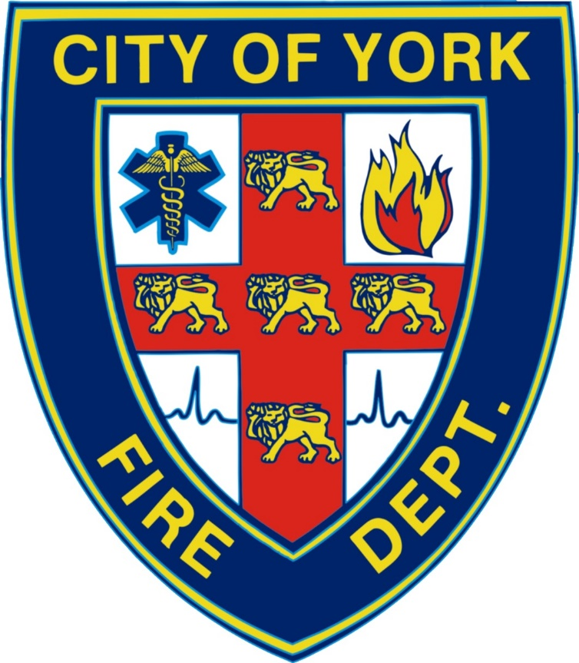

REQUEST FOR QUALIFICATIONS FOR YORK FIRE STATION BUILD

SUBMITTAL DUE DATE: FRIDAY, JUNE 30th, 2023

PROPOSALS MUST BE MAILED OR DELIVERED TO:
City of York, Attn: City Clerk
100 East 4th St., York NE 68476
Please mark your envelope “PROPOSAL FOR YORK FIRE STATION BUILD”

EIN/SSN (Required)___________________________________________________________
^{Federal I.D. Number}
COMPANY NAME____________________________________________________________

ADDRESS: __________________________________________________________________

CITY/STATE/ZIP_____________________________________________________________

PHONE_______________________________

PRINTED NAME_____________________________________________________________

AUTHORIZED SIGNATURE____________________________________________________

TITLE_________________________________ EMAIL_______________________________

Signature acknowledges that Proposer has read the bid documents thoroughly before submitting a proposal, will fulfill the obligations in accordance with the scope of work, terms and conditions, and is submitting without collusion with any other individual firm. You must submit this page with an authorized signature.

ALL QUESTIONS MUST BE SUBMITTED BY EMAIL TO THE FOLLOWING PERSON:

York Fire Station, Anthony Bestwick Chief, tbestwick@cityofyork.net

Questions must be submitted no later than Thursday, June 22, 2023. Questions submitted after that date will not be considered.

BIDDERS MUST SUBMIT THIS PAGE WITH ANY PROPOSAL

City of York
Request for Qualifications
Architectural and Engineer Services for a possible Fire Station to be located in York, Nebraska
May 30, 2023

Purpose:

The City of York, Nebraska (City) is seeking responses to this Request for Qualifications (RFQ) from interested parties for typical architectural and engineer services for a possible fire station to be built in York, Nebraska. The current address of the property is 1714 N Lincoln Ave., York, NE 68467. The approximate budget for the new fire station will be $10,000,000.

Terms and Conditions:
The city shall not be liable to any firm for costs associated with responding to this RFQ, the firm’s participation in the presentation, or any costs associated with negotiations.

This RFQ does not commit the City to enter into a contract. The City reserves the right to award one, more than one, or no contract(s) in response to this RFQ.

The City reserves the right to contact any respondent for clarification, interviews, or to negotiate a contract with the most qualified firm if such is deemed desirable by the City.

This RFQ aims to identify an experienced Architectural Services and Engineering firm with the best combination of qualifications, price, and best fit for the city.

The City of York is an equal opportunity employer and requires all contracts and consultants to comply with all applicable Federal and State laws and regulations.

The city reserves the right to reject any or all responses and negotiate any proposed changes.

Background:
York plans to construct a new fire station. The Fire Department is currently housed in a single station at 815 North Grant Avenue. They have called this location home for over fifty (50) years.

The York Fire Department is a combination fire department that also provides EMS services. They have 14 career, approximately 25 volunteer firefighters/EMS, and one (1) Fire Chief. In 2022 they ran a total of 1655 calls for service. The Department has (7) vehicles and the York Rural Fire Department has four (4) vehicles. This number of vehicles will change as our call volumes increase.

The City of York has a population of 8,000 and serves as the County Seat for York County. York is 50 miles west of Lincoln, Nebraska.

Contact:
All questions concerning the request for qualifications should be in writing and submitted to Anthony Bestwick, York Fire Chief by email at tbestwick@cityofyork.net or Dr. Sue Crawford York City Administrator, by email at scrawford@cityofyork.net.

SCOPE OF SERVICES

Scope of Work:
The city is seeking licensed professional architectural services for the programming and schematic design of the proposed new fire station in York. The following is an outline of the desired services to be performed:

- Needs Assessment – Work with the City and Fire Department subcommittee to determine facility needs for all elements of the project. This includes electrical, mechanical, technical, and site plan. Geotechnical surveys may have to be completed after the demolition of the existing building.
- Floor plan – Develop a floor plan for your proposed design that includes potential furniture and apparatus locations.
- Create a rendering/illustration and 3-D modeling of the facilities.
- Develop a statement of probable cost.
- Present the proposed design and costs to the York City Council.
- Develop full construction documents and specifications.
- Bid the project and support the city in selecting and securing a contractor.
- Construction administration through project completion, including quality control and cost control.

Note: The city will consider input from respondents as to other suggested services to be considered.

Design Requirements:
All designs shall comply with all applicable codes and ordinances. The services shall be performed in accordance with generally accepted professional standards, and all advice and consultation provided shall be within the architect’s authority and capacity as a professional. Compliance with all applicable codes, laws, ordinances, and regulations is required.

The schematic design should include the following subject to the Consultant’s advice and meetings with the Fire Department and City staff:
Chief’s Office – approximately 290 sq feet
Captain’s Office – approximately 250 sq feet
Another Admin office - approximately 250 sq feet
Conference Room / Classroom with a small kitchen in a corner – approximately 750 sq feet
Historic Display Area with Display Frames – approximately 500 sq feet
Day Room – approximately 766 sq feet
Classroom AV Storage – approximately 100 sq feet
Weight Room – approximately 1,350 sq feet
Dorm Rooms – Area to accommodate 6 private dorm rooms with room for expansion.
3 Dorm Restroom/Shower Rooms – approximately 160 sq feet each
Shop/Laundry/SCBA – approximately 300 sq feet
Watch Room with Dispatch Radio Console and Storage Closet of approximately - 200 sq feet
Bunker Gear and Staging Area – approximately 600 sq feet
Kitchen and Dining Room – approximately 700 sq feet
Open Office Area – approximately 600 sq feet
Clean Laundry Area – approximately 120 sq feet
Dirty Laundry Area – approximately 144 sq feet
IT Closet – approximately 60 sq feet
Administrative area bathroom approximately 150 sq feet
Ice Machine room- approximately 100 sq feet
Command Center/Storm Shelter – approximately 600 sq feet
Central Storage Room – approximately 2,162 sq feet
Decon Room with shower, lavatory, and water closet – approximately 150 sq feet
Apparatus Bay is 125 feet deep by 100 feet long – approximately 12,500 sq feet
Parking area provided for thirty (30) vehicles.
Public bathroom
Lobby
Hose Tower with Attachment for Confined Space Training approximately 35’ tall.
100’ communications Tower with a new repeater

Exit/Enter apron must be at least fifteen feet (15’) longer than the longest apparatus to allow for safe turning radius.

Meetings:
The Consultant will be required to meet 4 times with the City Administrator, Fire Chief, and the Fire Station Subcommittee at various stages throughout the project to provide updates and receive input. The Consultant may also be required to present their findings to the City Council to explain the details of the report, and the Consultant’s recommendations, and respond to any questions.

RFQ Submittal Requirements

Quantity and Format:
The Consultant shall provide two (2) copies of their proposal on 8 ½ x 11 paper. Consultants may be asked to submit a digital copy after the RFQ opening. All submitted information shall be organized generally as listed below. There is no minimum page requirement. Responses shall be limited to a maximum of fifteen (15) single-sided pages, not including a cover letter, cover page, tabs, or back page.

All responses must include the required City of York cover sheet.

Response Components:
To assist City in evaluating your submission, please include the information listed below. The response to this RFQ should be as concise as possible while adhering to the format and information requirements described herein. The response to this RFQ shall consist of the following sections:

- Section 1 – General Information
Provide the following information about each firm participating in the project (only submit information regarding the firm office(s) that will be involved in the project):
  - Name and address of firm(s)
  - Firm(s) contact name and information
  - Number of years in business
  - Total number of employees

- Section 2 – Project Organization
Provide the following information about each firm participating in the project:
  - If a team is proposed, explain the relationship of firms and what each firm will contribute to the project
  - Key personnel assigned to the project, organizational relationship presented in chart format, and project roles (i.e., Principal in Charge, Project Manager, Project Staff, etc.)
  - Abbreviated resume for each individual identified as key personnel above (Please limit to one page per person)
    - Briefly describe each team member’s role in this project.
    - Identify proposed sub-consultants
    - List of applicable Nebraska licenses

- Section 3 – Experience and References
Provide information for about three (3) to five (5) recent projects that illustrate the firm’s ability to perform the services required for this project. The projects should be directly associated with the key personnel identified in Section 2. For each project, provide the following information:
- Project name and location
- A brief description of the project
      - Contract value and construction value (original value plus contract, if applicable)
      - Dates of design and construction
      - Description of scheduled completion deadlines and actual completion dates.
      - Description of scheduled construction costs vs actual construction costs.
      - List and describe any actions commencing within the last seven (7) years including litigation, arbitration, claims filed by your firm against any project owner as a result of a contract dispute, claims filed against your firm, and termination from a project.
- Contact information for the owner’s project manager

- Section 4 – Project Approach
Discuss the following, as related to the proposed project:
- Demonstrate understanding of the project concept with a brief description
- Approach to planning, organizing, and project management, including communication procedures with the Fire Station Subcommittee, approach to problem-solving, quality control, approximate schedule, staff availability, and other similar factors.
- Identify any potential problems and anticipated actions to mitigate those problems
- Innovative strategies or technologies that could be applied to this project
- Provide a schedule and time frame for completion of the work.

- Section 5 – Cost
Provide an estimate for providing the services requested in the scope of work.

- Section 6 – Summary
Summarize your response and add any other comments that you feel would make your firm uniquely qualified to participate in this project.

Additional Services:
If it should become necessary to request additional services, such additional services shall be performed at the hourly rates for the key personnel.

Timeline:
All work for the project should be completed within eighty (80) calendar days after the Notice to Proceed is issued by the City. City Administrator will attempt to have all records and pertinent information available to the Consultant in a timely manner. The Consultant will be provided with the necessary contacts to assist in the compilation of the required data.

Deadline and Proposal Disposition:
Completed proposals shall be due NOT LATER THAN Friday, June 30th, 2023 at 2:00 PM.

All submittals shall become the property of the City. Proposals shall be submitted to:
Amanda Ring, City Clerk
City of York
Ref: Fire Station Architectural Services RFQ
100 East 4th Street
York, NE 68467

You may not respond with faxes or electric proposal submissions. All proposals must be submitted in a sealed envelope and clearly marked on the outside, “Fire Station Architectural Services RFQ.”

Selection

Selection Criteria and Process the City of York Fire Department intends to use the following criteria in evaluating submittals.
• Relevant project experience
• Qualifications of firm project personnel
• Past record of performance on relevant projects, quality of work, cost control, and ability to meet schedules.
• Project approach with a focus on firm strategies to ensure our project goals are met within our budget and schedule.

Submittals will be distributed to members of the City of York staff for review and ranked based on the evaluation criteria above. The City of York reserves the right to conduct interviews to better inform the judgment of the city concerning the most qualified consultants. The City of York reserves the right to select the most qualified firms to enter into the bidding round of selection. Once the qualified consultants have been selected, the City of York will invite said qualified contractors to submit bids for their costs for the project. The lowest responsible bid from the qualified consultants will be selected.

Proposed Timeline:
The city will attempt to adhere to the following schedule. However, City reserves the right to change, alter, or modify the schedule, as needed, and will notify firms in writing of any significant changes.

- Qualifications submittal deadline – Friday, June 30th, 2023, 2:00 pm
- Tentative Interviews – week of July 3rd-12th, 2023
- Negotiation of contract, the scope of services, etc.
- Recommendation to City Council – July 20th, 2023 or August 3rd, 2023
- Anticipated Notice to Proceed with work – Friday, July 21st or August 4th, 2023
- Anticipated Completion – Thursday, October 10th, 2023 or October 24, 2023

Land closing: April 1, 2024
Demolition required before build.

